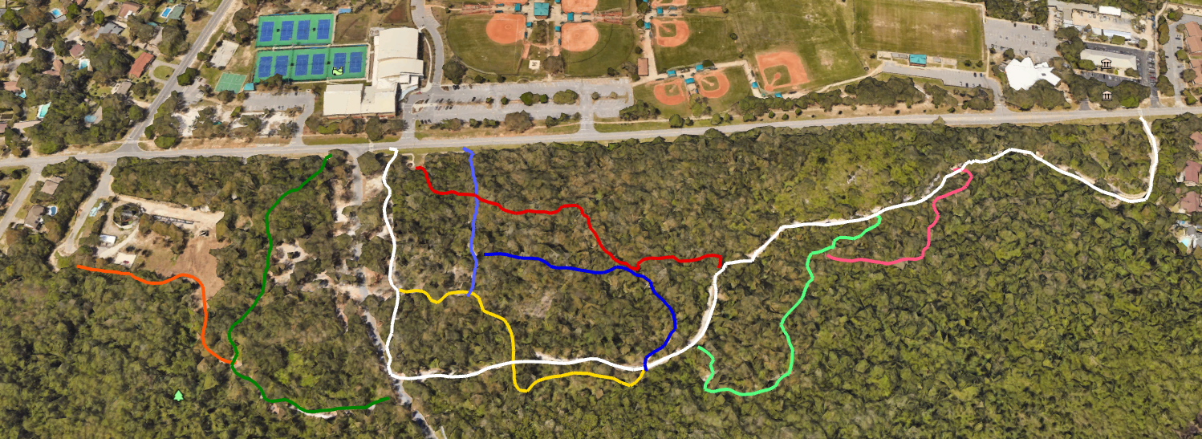

Laurel Oak Trail

Bench Oak Trail TraiTrail

**SHORELINE SOUTH PARK NATURE TRAILS**

Shoreline Loop

Eagle’s Nest

Sand Pine Trail

Bark Park Alley

Winding Way

Heritage Oak Trail

Mulberry Trail